
full stack web development lab
Ms. Fiza Asmat

hassan shahid
241790
bscs 5c

LAB 06

LAB Task:
Task 01:
Html file:
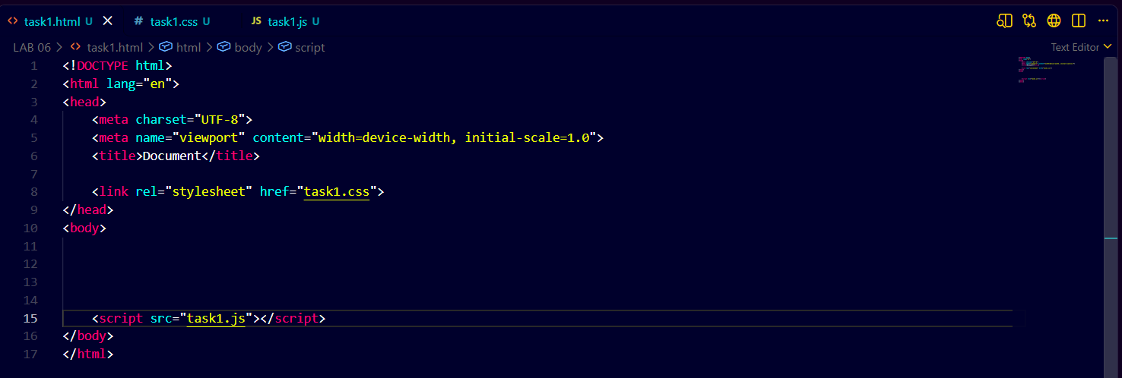
Js file:
Timeout Function:
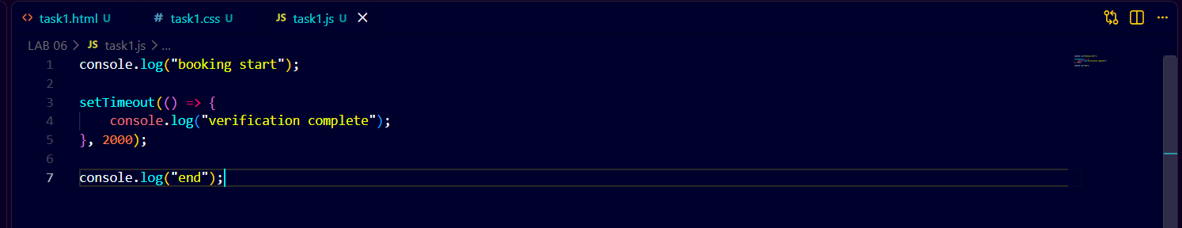
Callback Function:
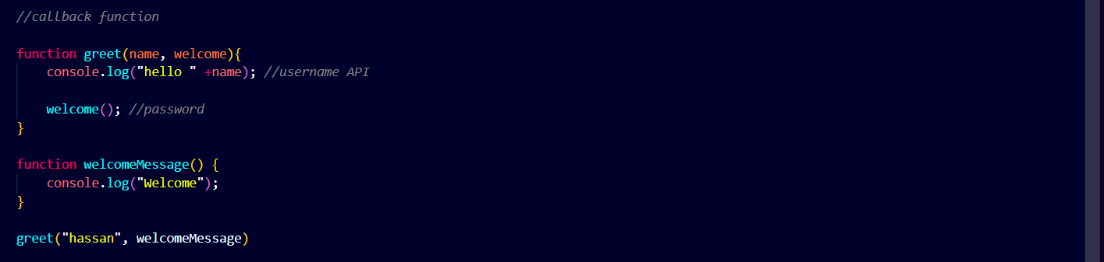
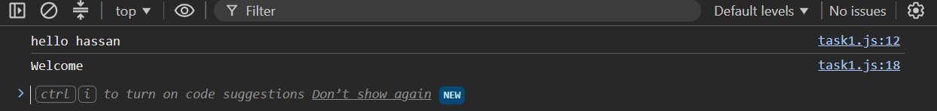
Async Callback:
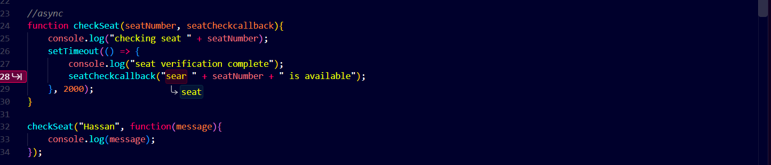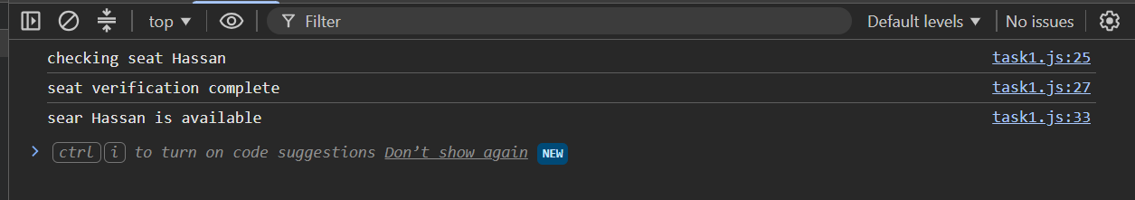
Nested Callbacks:
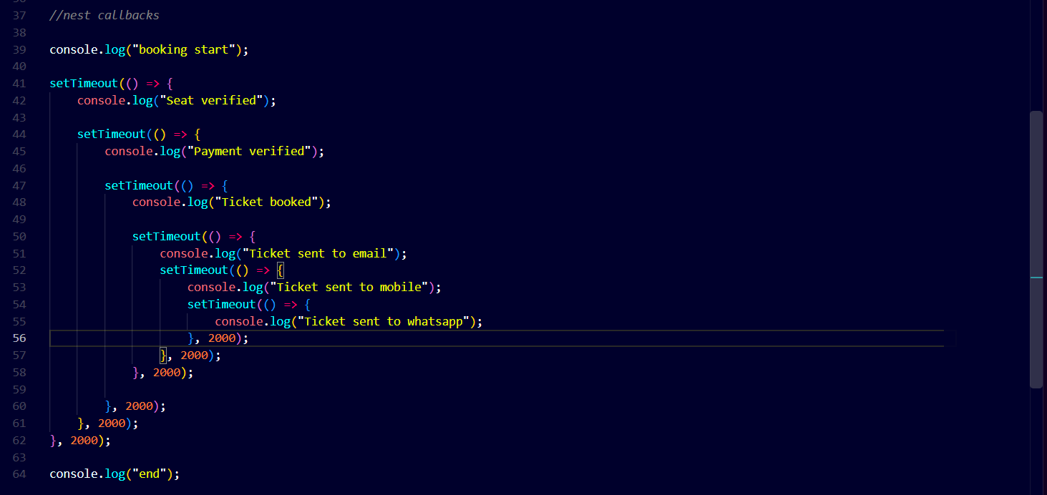
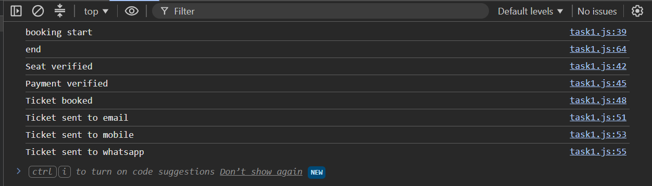
Promises:
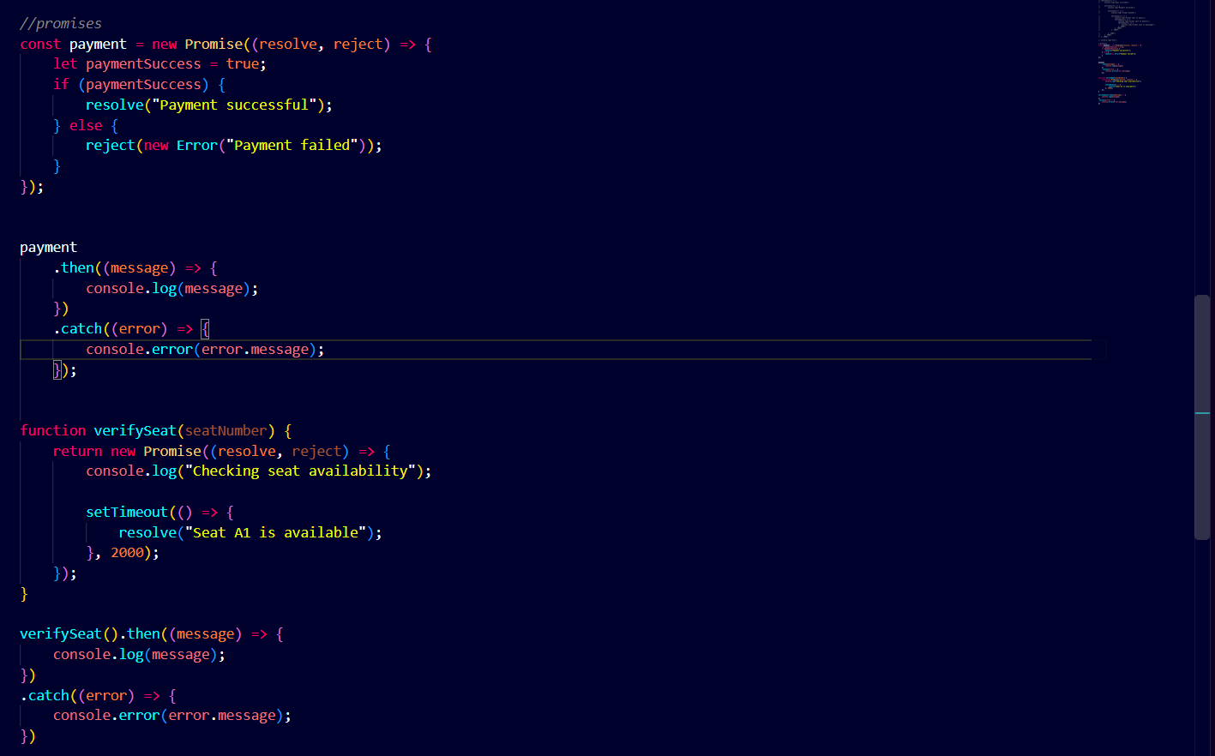
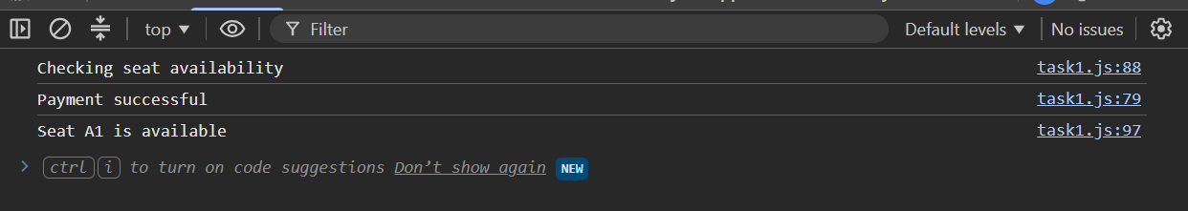
Nested callbacks to promises:
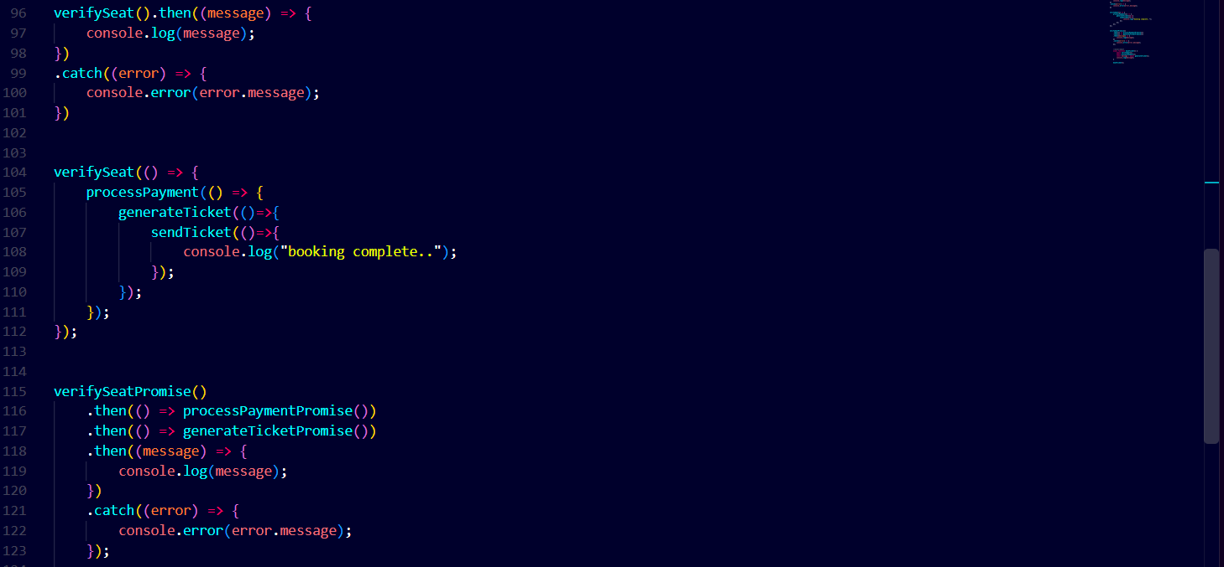
Async/Await:
